CoMP technique is one of the most important technologies in LTE-Advanced systems, which can effectively eliminate inter-cell interference. The technology provides services to users in CoMP area through multiple BSs in the coordinated set at the same time, it can be used to improve the spectrum efficiency of cell edge users and the overall performance of the system However, CoMP technique requires joint scheduling of multiple BSs and realizes multiple BSs cooperative communication for user equipment (UE), which increases the complexity of CoMP techniques and the difficulty of multiple BSs participating in CoMP transmission in the uplink for baseband signal processing.

The millimeter wave has the characteristics of narrow beam and wide bandwidth. The received signals power under the condition of line-of-sight (LoS) propagation is much better

than that multipath channels caused by reflection or refraction, but its signal is seriously fading by obstacles . For future wireless mobile communications, such as 5G mobile communication, signals transmission can be realized based on millimeter wave, and the application of CoMP technology may further improve the utilization of system resources . While most of previous studies concentrate on user scheduling algorithm and resource allocation based on CoMP technology , and the problem of signals diversity processing of different BSs in CoMP area for uplink is not involved. Therefore, in CoMP communication, it is necessary to consider how transmission signals from more than one BS can be processed in a BS.

we propose a new method to deal with diversity combining of signals from different BSs for uplink CoMP transmission in a millimeter wave communication system. According to the SNR of the receive antenna, the diversity signals of different BSs are selected and processed in one BS, this method achieves signal diversity of different BSs. Moreover, the complexity of the system is reduced and the overall performance of the system is improved on the basis of

reducing the paths of each BS participating in signal diversity.

The uplink signals transmission model in CoMP system is as shown in Fig.1. Here, when a UE enters an area where multiple BSs communicate together, the area is called CoMP

area. Suppose that in the CoMP area, the number of BSs whose SNR received by the receive antenna is higher than the system SNR threshold is R. The corresponding R BSs compose a

CoMP group BS. In practice, there may be multiple UEs entering the CoMP region at the same time, but this article only discusses the situation when a UE enters the region.

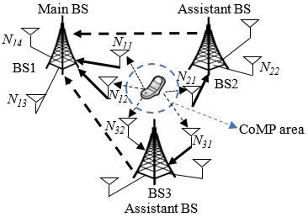

Fig. 1. Uplink CoMP transmission model.

Considering that each UE uses a single antenna to transmit signal. Each BS has Nr receive antennas. In this system, OFDM modulation and demodulation techniques are used in the transmitter and receiver, respectively. Assuming that the number of symbol subcarriers is N. Signals after FFT operation, the received signals of the antenna can be depicted as



where S(k) is the complex symbol of the kth subcarrier, H(k) is the channel frequency response of the kth subcarrier, and N(k) is the additive white Gaussian noise (AWGN) component.

Assuming that each UE in the CoMP area transmits signals through independent flat Rayleigh fading channels , and these signals respectively reach n receive antennas of a BS, So, for the UE, the channel can be equivalent to 1 \* n SIMO channel model. the SNR of the receiver is given by

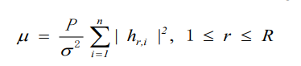

where P is the total transmitting power of the UE, hr,i is the channel gain of ith receive antenna of rth BS. The channel capacity can be expressed as

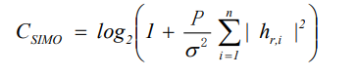

In CoMP communication, there are multiple BSs to communicate with the UE, and each BS also has multiple receive antennas or huge antenna arrays, but some antennas just receive a little signal power. Therefore, it is impossible to process the received signals of all antennas in practice. In addition, LoS propagation is better than other non-LoS paths in millimeter wave communication. Therefore, the receiver is easier to distinguish the main first and second paths, and the interference of other weak signal paths is also smaller.

Considering the complexity of the system in receiver signal processing and the characteristics of millimeter wave communication, the BSs of a CoMP group are appointed as the main BS and assistant BSs according to the SNR of the receive antenna of each BS in this paper. There is only one main BS and one or more assistant BSs in each CoMP group BSs. For a UE, the main BS can choose more than one receive antenna which have SNR higher than the threshold SNR, while each assistant BS only uses one receive antenna which has the maximum SNR. Signals of these receive antennas are diversity combining at the main BS.

Assuming that the BS that first communicates with the UE is the original main BS, the total number of paths that the system defines diversity combining is q. The SNR threshold of

the receive antenna participating in diversity combining is q.

The flowchart of the diversity combining of signals from different BSs in CoMP communication is as shown in Fig.2. The specific steps are as follows:

Step 1: The original main BS detects whether there is a new BS to apply for CoMP communication. If not, the main BS judges whether the old BS needs to be separated from CoMP communication and performs corresponding subsequent operation. Otherwise, the original main BS judges whether the new BS can join and perform CoMP communication according to the SNR of the receive antenna.

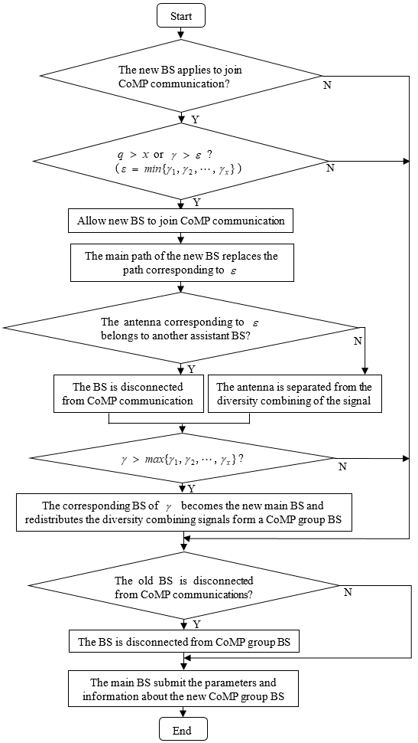

Fig. 2. Flowchart of the diversity combining of signals from different BSs inCoMP communication.

Step 2: When a new assistant BS is added, the original main BS comprehensively considers the SNR of the all receive antenna with diversity combining of signals, and decides whether to hand over the main BS to other BSs. If the main BS is replaced, the new main BS performs the power of the main BS. Then it will reassign the path of diversity combining and the CoMP group antenna. and the relevant parameters and information of the new CoMP group are reported to the upper network node. If the original main BS is maintained, the original main BS will perform subsequent processing. If there is the third BS requesting to participate in CoMP communication, the main BS, as the original main BS, is responsible for evaluating whether the third BS can join the CoMP group communication, and so on. This paper is based on the above method to realize the diversity combining of signals from different BSs in CoMP communication.

Consider the system described in Fig. 3, for the UE, two BSs perform CoMP communication, and each BS has 4 receive antennas. Assuming that the maximum number of diversity paths is 4 in this system. If the UE initially only communicated with BS1, at this time, the diversitycombining signals are from receive antenna N11, N12, N13 and N14of BS1 in uplink

transmission. When the UE enters the CoMP area, the BS1, the original main BS, detects that BS2 applies to join CoMP transmission. BS1 judges that the UE to the antenna N11 is the path with the largest SNR of all receive antennas, which is the main path of the UE to BS1. Similarly,BS2 judges that the path from UE to the antenna N21 is the main path from UE to BS2. When the SNR of the BS2 main path is higher than the SNR threshold and is higher than the minimum SNR of the receive antenna of BS1, BS1 and BS2 constitute a CoMP BS.

At the same time, if the SNR of BS1 main path is higher than the SNR of BS2 main path, then BS1 is still the main BS and BS2 is the assistant BS. When less than three paths in BS1 exceed the threshold SNR, because the maximum number of diversity paths in this system is the multiple paths of signals diversity combining in BS1 have one main path of BS2 and the

other paths of BS1 higher than threshold SNR. Otherwise, the four paths of signals diversity combining in BS1 have three paths for UE to BS1 receive antenna higher SNR and one main path of BS2.

If the SNR of BS1 main path is lower than the SNR of BS2 main path, then BS2 will replace BS1 as the main BS, while BS1 will participate in CoMP transmission as the assistant BS. At the moment, BS2 will recalculate the number of new paths and antennas participating in uplink diversity processing. After BS2 serves as the main BS, it is known that the maximum number of diversity paths in this system is 4, the multiple paths of signals diversity combining in BS2 have one main path of BS1 and the other paths of BS2 higher than threshold SNR.

The simulation experiment is completed by the Matlab platform. In this paper, the simulation model is 64QAMOFDMsystem. The millimeter wave communication is mainly

based on LoS propagation, and the flat Rayleigh fading channel can be regarded as single-path propagation. Consequently, the channel model adopts flat Rayleigh fading channel with

AWGN signal. The simulation parameters of the specific uplink system are shown in Table 1.

TABLE I. THE SIMULATION PARAMETERS OF THE UPLINK SYSTEM

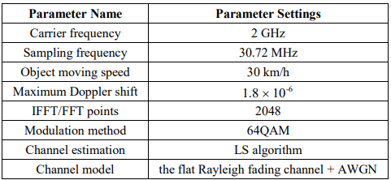

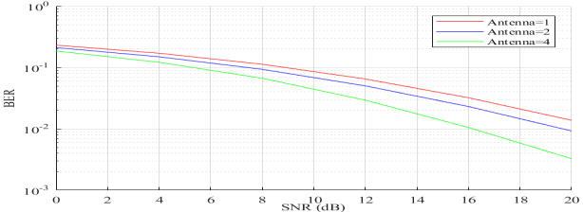

Fig. 4. BER of signals diversity combining with different antenna numbers.

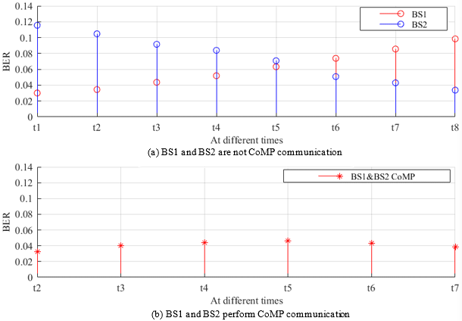

Fig. 5. BER performance of the signal after receiver diversity combining at

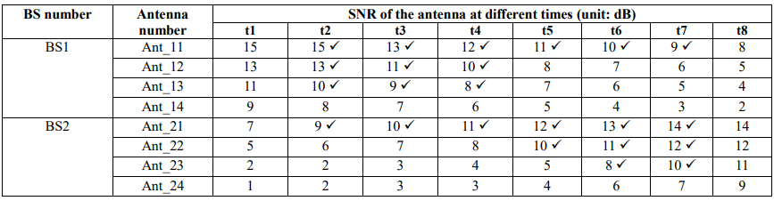

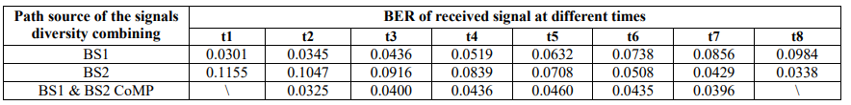

TABLE III. THE BER OF THE SIGNAL AFTER RECEIVER DIVERSITY COMBINING AT DIFFERENT TIMES

When the number of receiving antennas of BS is 1, 2 and 4 respectively, the BER of the signal after the receiver diversity combining changes with SNR as shown in Fig. 4. Obviously,

the more antennas participating in the diversity combining, the lower BER of the signal after diversity combination. The more antennas involved in the diversity combining and the diversity effect is better, but the complexity of the receiver is increased. In uplink CoMP transmission system, for the system described in Fig. 3, it is assumed that the maximum number of diversity combining path is 4. The SNR threshold of the CoMP antenna is 6 dB. When the UE moves, suppose that the SNR of each antenna on each BS changes as shown in Table 2. (For each BS, the position of the antenna with the largest SNR is not fixed, and it can be any one of the antennas in the BS.) In Fig. 5, the curve is drawn according to the situation

described in Table 2. Among them, Fig. 5(a) corresponds to all data at different times in Table 2, and Fig. 5(b) only corresponds to "✓" data at different times in Table 2, which is the receive antenna selected according to the method in this paper. With the UE moving, if the UE has just started to communicate with BS1 at the time of t1, BS1 is the main BS.

When the time from t1 to t2, BS2 applies for CoMP communication with BS1. At this time, BS1 is still the main BS1 and BS2 is the cooperative BS. When the time from t4 to t5, the mainBS changes from BS1 to BS2. However, only two antennas in BS2 have SNR greater than 6 dB, only signals of three paths participate in diversity combining. At time t8, the BS1 is out of CoMP communication, and the UE only communicates with BS2. The BER of the signal after receiver diversity combining at different times is shown in Table 3.

According to Table 3, it is more obvious that this paper proposed method has a lower BER of the signal after receiver diversity combining.

A new method for the diversity combining of signals from different BSs is proposed for uplink CoMP transmission in a millimeter wave communication system, which can be really

realized in practice. The simulation results show that the proposed method not only ensures the reliability of the system by a lower bit error rate, but also greatly reduces the complexity of the system signals processing by selecting fewer diversity combining paths.